XI. INTERNATIONAL CONFERENCE ON HEMORHEOLOGY AND MICROCIRCULATION

3–5 July 2017
Yaroslavl, Russia

INTERNATIONAL SOCIETY OF CLINICAL HEMORHEOLOGY (isch)
RUSSIAN SOCIETY OF HEMORHEOLOGY AND MICROCIRCULATION
Moscow State university
Yaroslavl STATE Pedagogical University
Yaroslavl STATE Medical Academy

Dear Colleague,

The Organizing Committee invites you to attend the 11-th International Conference on Hemorheology and Microcirculation that will be held on July 3 – July 5, 2017, in center of Russia, in the ancient Russian town Yaroslavl that is situated on the great river Volga. This is a city where the history of Russia comes to life. Its face bears traces of different times and epochs, white walls of old churches stand out against the greenery of numerous trees. Yaroslavl attracts tourists as a city of rich artistic heritage passing a lot of specimens of old architecture and painting. Magnificent views open from the steep banks of the rivers Volga and Kotorosl.

A.V. Muravyov
Chairman of Organizing Committee

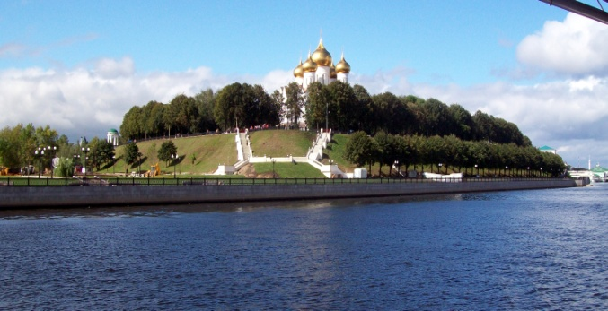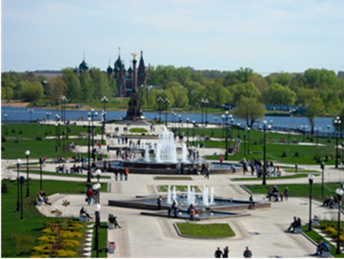

Organizing Committee:

Alexei.V. Muravyov, Chairman
N.V. Kislov
V.V.Yakusevich,
Svetlana Bulaeva (conference secretary)
E.V. Roitman
A.A.Muravyov
I.A. Tikhomirova
A.A. Baranov
P.V. Mikhailov
A.S. Petrochenko
A.G.Guschin

Conference Secretariat (Registration, Accommodation etc.)
Dr. Svetlana Bulaeva and Dr. Pavel Mikhailov

Respublikanskaya 108,
Pedagogical University,
mail box 25, 150000, Yaroslavl, Russia
Phone: 0097 (4852) 72 86 33
Fax: 0097 (4852) 30 55 96
E-mail - conf.hemorheology.yar@yandex.ru, alexei.47@mail.ru
http://www.yspu.org

GENERAL INFORMATION

Date and venue
From Monday, July 3 to Wednesday, July 5 at:
Pedagogical University, Kotoroslnaya str. 46в, Yaroslavl, Russia

Official Language: Russian and English

MAIN SCIENTIFIC TOPICS

- Molecular change mechanisms of the blood cell microrheological control
- Hemorheology, Hemostasis and Microcirculation under normal and pathological conditions
- Hemorheology, microcirculation and hemostasis in the surgical treatment of cancer patients
- Hemorheology, microcirculation and hemostasis in the chemotherapy of cancer patients
- Laser Doppler Flowmetry and tissue oxygenation: clinical and experimental researches
- Adaptation, stress and physical activity: the role of the microcirculatory and hemorheology change mechanisms
- Regulatory mechanisms and microrheological properties of blood cells and endothelial functions
- Hemorheological disorders in the clinic of cardiovascular, cerebrovascular, renal and pulmonary diseases
- Red blood cell aggregation and deformation: clinical applications
- Therapeutic haemapheresis, transfusion and hemorheology
- Methodology and instruments
- Miscellaneous

Plenary lectures
Intended to give a broad view of special leading subjects and to orient for future research. Each will be allocated 30 minutes. No questions will be allowed following the plenary lectures

Oral presentation
Selected abstracts will be presented in sessions of 15 min. Each oral communication session will include 6 to 8 oral presentations, plus one invited lecture of related topic. The organization anticipates that most of the oral communications will be selected from poster presentations.

Poster presentation
Certain topics are more suitable to be presented in form of a poster allowing for ample discussion. Possibilities to discuss posters will include poster sessions.

Registration details
Registration is required for all participants and accompanying persons (Includes admission to reception, coffee breaks, bus transfer to official events, abstract booklet)

Registration fees (in Euro)
Participants: 50.00 Euro
Medical Students (Postgraduate, Postdoctoral students): free registration
Accompanying persons: free registration

Abstracts presentation
The entire abstract must not exceed 250 words, including title, names of authors (underline name of presenting author), and institution (s)
- The abstract must fit into a space 16 cm (width) x 10 cm (height). Use a white sheet of paper (A4) not to be folded for mailing
- The title should be all in capital letters, except formulae
- A structured form is required: Use the headings (if pertinent): BACKGROUND, OBJECTIVE, MATERIAL/METHODS, RESULTS, CONCLUSION, typed in capital letters.

Deadline for abstract submission is 31th May 2017

Accommodation
Accommodation in various price categories has been reserved through Yaroslavl Tourism for congress participants: www.boocing.com or http://www.hotelclub.net/hotel.reservations/Yaroslavl.htm
You will find a list of all reserved hotels as well as their rates and location.

Yaroslavl location
Yaroslavl is situated 250 km from Moscow (in North direction) and it can be reached by train or bus. Useful information about train trip to Yaroslavl could be found here: http://www.poezda.net/en/index or www.tu.tu.ru

Commercial Exhibition
Commercial firms will form an interesting exhibition which gives all participants the possibility to get informed on drugs, laboratory tools and many more. The exhibition will be open during all two days of the meeting.

Weather and clothing
The weather in Yaroslavl in June usually warm. Temperatures range: from 22-26⁰ C. Clothing is informal for all occasions.

Attendance Certificates
Certificate of Attendance will be available from the Congress Secretariat on request.

Currency and Banking
The currency in Russia is the Russian ruble. One Euro corresponds to 62.0 rubles*; one dollar corresponds to 57.0 rubles*. Money can be easily exchanged at banks and exchange offices, travel agencies and hotels.

* Average exchange rate in May 2017 and subject to change
Credit cards
All major credit cards, such as MasterCard – Eurocard, Visa, American Express etc. are accepted in banks and hotels.
Please note that identification (passport) is requested when exchanging money. All banks in Russia are authorized to convert foreign currency to Russian ruble.
Electricity
Main voltage in Russia is 220 V at 50 Hz. Electric sockets only accept round-prong plugs.
Taxi
A taxi service in Yaroslavl is available day and night.
Liability and insurance
The organizing committee accepts no liability for personal injuries or for loss /damage of property belonging to congress participants, either during or as a result of the congress or during any of the excursion tours. It is recommended that participants arrange for their own personal health, accident and travel insurance.
Passport and visas
For visitors from all countries, it is recommended to check document requirements with the Russian embassy or consulate in their country of residence. Delegates requiring a letter of invitation for visa purposes are kindly requested to write to the congress organizers.
Telephone
The country code for Russia is 007; the area code for Yaroslavl is 4852.
Public telephones
So called «taxcards» for public telephones are sold at post offices, train stations or at any newsstand. Operating instructions are displayed in the telephone booths, which can be found at post offices and in various other locations.
Mobile telephones
Contact your provider for any additional information on the operation of your mobile telephone abroad. Please note that you might need an adapter for recharging in Russia and that mobile telephones must be switched off during congress sessions.
Social events

Excursion around Yaroslavl (included in the registration fee)
Tuesday, July 4: 14.00 - 17.30.
Welcome party (Yaroslavl, Kotoroslnaya st. 46в)
Monday, July 3: 18.00 - 20.30 (included in the registration fee)
Conference dinner
Tuesday, July 4: 19.00 - 22.00
(Dinner fee is 25 Euro)

Sample abstracts

BLOOD RHEOLOGY ABNORMALITIES AND VASCULAR CELL ADHESIONS
MECHANISMS IN SICKLE CELL TRAIT CARRIERS DURING EXERCISE
Philippe Connes1, Olivier Hue1, Julien Tripette1,2 and Marie-Dominique Hardy-Dessources2
1Laboratoire ACTES (EA 3596), Departement de Physiologie, University des Antilles et de
la Guyane, Guadeloupe, pconnes@yahoo.fr – 2UMR-Inserm U763/University des Antilles
et de la Guyane, Pointe-а-Pitre, Guadeloupe, F-97159 France.

Sickle cell trait (SCT) is usually considered a benign disorder compared with sickle
cell anemia (SS hemoglobinopathy). However, several authors reported cases of exercise-
related sudden death in this population. Among mechanisms that could be involved
in these fatal complications, those involved in the vasoocclusive processes of SS hemoglobinopathy could play a role. Therefore, we have developed different studies in order
to assess the effects of exercise on biological parameters potentially involved in the
vaso-occlusive processes. We have compared the kinetics of red blood (RBC) rigidity at rest, during a prolonged and intense exercise, and during the immediate and late recovery between a group of SCT carriers and a control group. We found that RBC rigidity increased above resting
values in the two groups 24 and 48 hrs after exercise but the increase was greater in SCT
carriers. In addition, we have followed the kinetics of several adhesion molecules in
response to three repeated maximal ramp exercise tests. Molecules such as the vascular
cell adhesion molecule (VCAM-1), which plays a role in the firm adhesion of reticulocytes
to endothelial cells, and L-selectin which plays a role in leucocyte rolling on vascular
wall, have been tested. Although VCAM-1 was not different between the two groups and
remained unchanged with exercise, we found an increase in L-selectin in the two groups and
this increase was faster in SCT carriers compared to a control group. L-selectin increased
above basal values 24 hrs after the end of exercise in the control group whereas, this increase
was observed immediately at the end of exercise in SCT carriers.
In conclusion, we can suggest that the risks for micro vascular complications in
SCT carriers in response to exercise could be dependent on changes in blood rheology
and vascular adhesion processes.

